Task 3

1. Explore on mv command for dir’s?

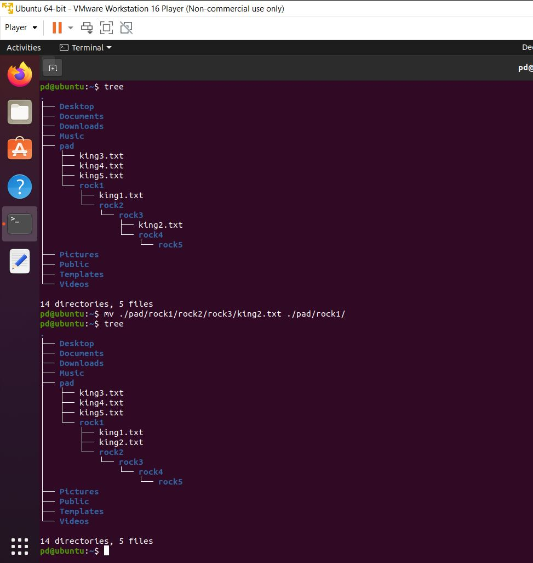

1. What is the use of ls –a command and whoami command?

Sol:

1. (ls –a): It shows all the files and including hidden .
2. Whoami : It shows the current user.